CS 6375

ASSIGNMENT _____3_______

Names of students in your group:

Pranathi Peri (pxp162530)

Nithin Vasireddy(nxv160230)

Number of free late days used: _________0___________   
Note: You are allowed a **total** of 4 free late days for the **entire semester**. You can use at most 2 for each assignment. After that, there will be a penalty of 10% for each late day.

Please list clearly all the sources/references that you have used in this assignment.

**Report**

**Assumptions:**

1) Activation Function is sigmoid.

2) We have used back propagation algorithm described in Tom Mitchell Text book.

3) We have used mean square error as error metric.

4) Training data is randomly sampled from the dataset.

5) For each row in training dataset a forward and a backward pass of the backpropagation algorithm is implemented.

6) We have designed an algorithm in a way that it run until a fixed number of iterations (2000) or the error is less than error tolerance.

7) We have assigned the initial weights randomly.

8) We took the Last column as class.

9) We Initially changed the categorical values to numeric values and later we had standardized the class values so that they lie between (0,1).

10) We have returned 0 when the value of e^(-net) tends to infinity and returned 1 when the value of e^(-net) tends to zero.

**Results:**

The output for Iris Data set:

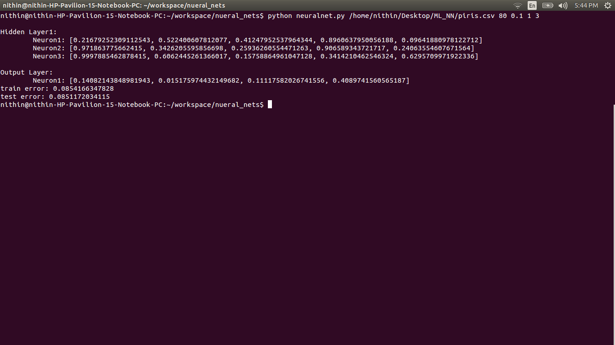

The output for Adult Data Set:

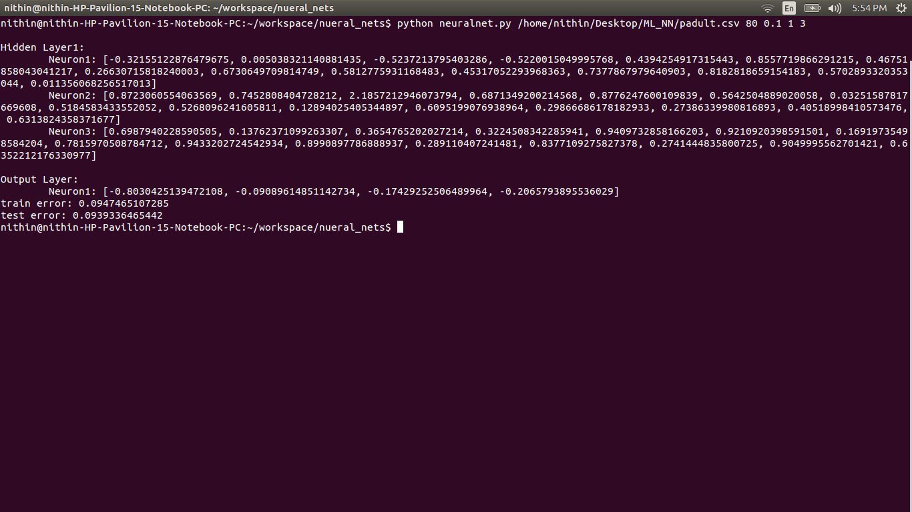

The output for Housing Data Set:

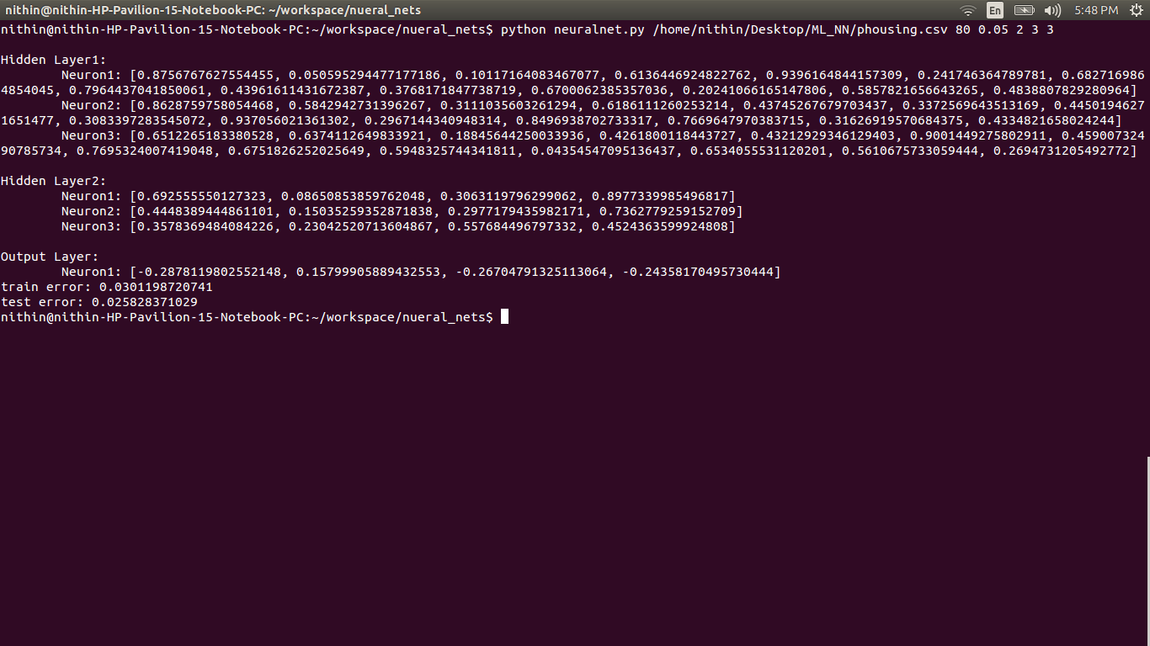

**Best set of Parameters:**

**For Iris Data set:**

Training percentage = 80

Error tolerance = 0.02

Number of hidden layers = 1

Number of nodes in hidden layer = 3

**For Housing data:**

Training percentage = 80

Error tolerance = 0.02

Number of hidden layers = 1

Number of nodes in hidden layer = 6

**For adult data:**

Training percentage = 80

Error tolerance = 0.1

Number of hidden layers = 2

Number of nodes in first hidden layer = 6

Number of nodes in second hidden layer = 3